**CS106.3**

**Algorithms and Data Structures**

**Lab 3**

**Queue**

1. Implement Queue data structure using enqueue() dequeue() and display() functions. Use Switch case to get test cases from user.

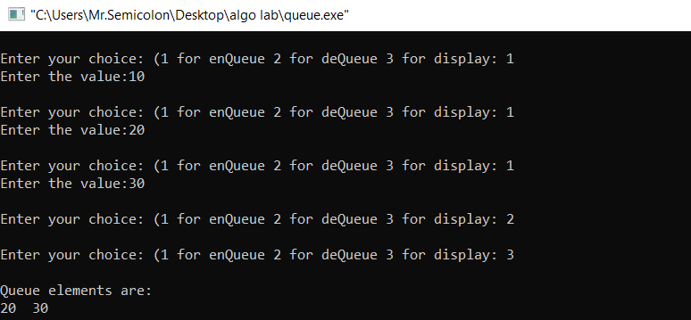

1. Implement Circular Queue data structure using enqueue() dequeue() and display() functions. Use Switch case to get test cases from user.

